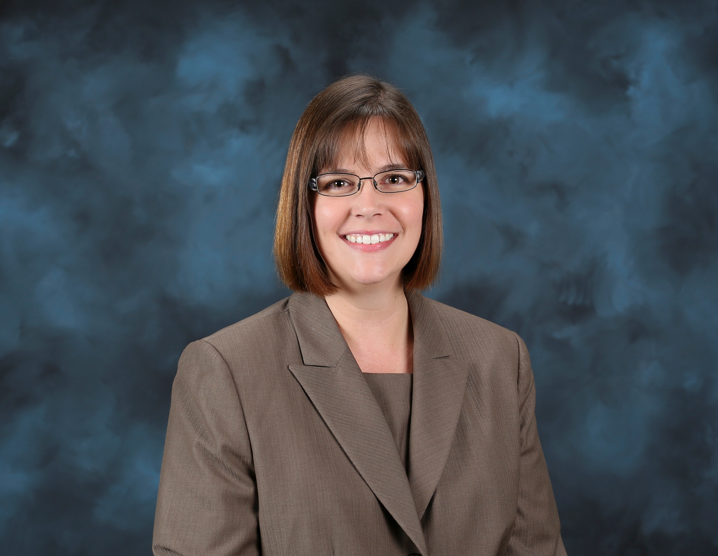

**Wilson, Leslie L.**

Master Technician

Nanofabrication Research Laboratory

Center for Nanophase Material Sciences

Oak Ridge National Laboratory

(865) 574-4922

wilsonll@ornl.gov

**Education**

University of Tennessee, Knoxville, TN

2000 B.S. Biology with Minor in Chemistry – Magna Cum Laude

**Professional Experience**

10/16 – Present Technician at the Center for Nanophase Material Sciences at Oak Ridge National Laboratory

1/05 – 10/16 Technician in Chemical Sciences Division at Oak Ridge National Laboratory

2/03 – 1/05 Technician at Oak Ridge Associated Universities, performing work in the Chemical Sciences Division at Oak Ridge National Laboratory

**Awards**

2023 Physical Sciences Directorate Technician Award: One ORNL Award – for cross-directorate and beyond impact through production of nanodiamond stripper foils.

2020 ORNL Continuous Improvement Award - for multiple mission-critical accomplishments in the stripper foil R&D program, including the development of foils that survive 1.4 MW of beam power for an entire three-month neutron production cycle and the first-ever experimental determination of the foil failure limit that retired a single-point-of-failure risk for the Spallation Neutron Source 2.8 MW Proton Power Upgrade project.

2016 ORNL Mission Support Award – for successful execution of a complex project to improve the synthesis, production, and performance of the diamond stripper foils that are essential to the operation of the Spallation Neutron Source.

2013 ORNL Technical Support, Individual – for outstanding contributions to the creation of high-quality stripping foils critical to SNS operations.

2007 ORISE Award – in recognition of your dedication to the education of future scientists and engineers and your support of educational programs at Oak Ridge National Laboratory

2007 United States Department of Energy Office of Science Outstanding Mentor Award

**Publications**

* Zijun Shao, Leslie Wilson, Yuanyu Chang, and B. Jill Venton, “MPCVD-Grown Nanodiamond Microelectrodes with Oxygen Plasma Activation for Neurochemical Applications,” *ACS Sens,* 2022, 7, 3192-3200.
* Leo Saturday, Chris Luck, Leslie Wilson, Jason D. Fowlkes, Philip D. Rack, Nicholas J. Evans, “Experimental and simulated heating in nanocrystalline diamond charge exchange injection films using an electron beam to mimic SNS conditions,” *Nuclear Inst. And Methods in Physics Research, A*, 1027, p. 166226, 2022.
* Leo Saturday, Leslie Wilson, Scott Retterer, Nicholas J. Evans, Dayrl Briggs, Philip D. Rack, and Nickolay Lavrik, “Thermal conductivity of nano- and micro-crystalline diamond films studied by photothermal excitation of cantilever structures,” *Diamond and Related Materials*, Vol. 113, p. 108279, 2021.
* E.P. Barrowclough, C.S. Feigerle, C.F. Luck, L.L. Wilson, R.W. Shaw, and M.A. Plum, “Analysis of primary stripper foils at SNS by an electron beam foil test stand,” PAC2015, Richmond, VA, p.1230.
* R.D. Vispute, Henry K. Ermer, Phillip Sinsky, Andrew Seiser, Robert W. Shaw, Leslie L. Wilson, Gary Harris, and Fabrice Piazza, “Nanodiamond Foils for H- Stripping to Support the Spallation Neutron Source (SNS) and Related Applications.” *MRS Online Proceedings Library* **1634,**303 (2014). <https://doi.org/10.1557/opl.2014.704>
* R. Vispute, Henry Ermer, Phillip Sinsky, Andrew Seiser, Robert W. Shaw, and Leslie L. Wilson, “Development of nanodiamond foils for H- Stripping to Support the Spallation Neutron Source (SNS) Using Hot Filament Chemical Vapor Deposition.” *Vacuum Technology and Coatings* **15**, 35 (2014).
* R.W. Shaw, D.P. Bontrager, L.L Wilson, C.S. Feigerle, C.F. Luck, and M.A. Plum, “An electron beam SNS foil test stand,” PAC09 Vancouver, BC, p.1638.
* R.W.Shaw, M.A.Plum, L.L.Wilson, C.S.Feigerle, M.J. Borden, T. Spickermann, Y. Irie, I. Sugai, and A. Takagi, “Spallation Neutron Source (SNS) Diamond Stripper Foil Development,” PAC2007, Albuquerque, NM, p. 620.
* R.W.Shaw, V.A.Davis, R.N.Potter, L.L.Wilson, C.S. Feigerle, M.E. Peretich, and C.J. Liaw, “Corrugated thin diamond foils for SNS H- injection stripping,” PAC2005, Knoxville, TN, p. 2152.
* Donald Palmer, Lawrence Anovitz, David Cole, Mostafa Fayek, Miroslaw Gruszkiewicz, L. Riciputi, D. Wesolowski, and L. Wilson, “Experimental approaches to predict the behavior of liquid films.” *Geochimica et Cosmochimica Acta Supplement*. 2005.