CURRICULUM VITAE

Yury Osetskiy (aka Yuri Osetsky, Iouri Osetski)

Address: Oak Ridge National Laboratory
bldg. 4500S, MS-6138
P.O. Box 2008, Oak Ridge, TN 37831-6138
Tel. (01) 865 576 3254
Fax: (01) 865 241 3650
e-mail : osetskiyyn@ornl.gov

Birth date and place May 3, 1959, L’vov, USSR

Citizenship USA, UK, Russian Federation

Education

1986-1991: Ph.D. in physics and mathematics. Doctoral thesis "Investigation of vacancy clusters nucleation mechanisms in high-energy displacement cascades". Department of Radiation Materials Science, Division of Testing Reactors and Reactor Technology, I.V.Kurchatov Atomic Energy Institute (Moscow, USSR).
1976 -1982: B.Sc+M.Sc in materials science with high distinctions. Master thesis : “Computers Simulation Study of Point Defects in HCP Metals”. Department of Materials Science and Metal Physics, Moscow Engineering Physics Institute (Moscow, USSR).

Professional experience

01/2008 - : Senior R&D Staff Member, Materials Science and Technology Division, Oak Ridge National Laboratory, USA.
01/2007- 01/2008: Senior R&D Staff Member, Computer Science and Mathematics Division, Oak Ridge National Laboratory, USA.
03/2003-12/2006: R&D Staff Member, Computer Science and Mathematics Division, Oak Ridge National Laboratory, USA.
05/2005 - /2015: Visiting Professor, Materials Science & Engineering, Dept. of Engineering, University of Liverpool, UK.
11/1998-03/2003: University Research Fellow, Materials Science & Engineering, Dept. of Engineering, University of Liverpool, UK.
11/1997-11/1998: Research Associate, Materials Science & Engineering, Dept. of Engineering, University of Liverpool, UK.
3/1995-10/1997 : Visiting Professor, Dept. of Applied Mathematics, School of Civil Engineers, Polytechnic University of Catalunya (UPC), Barcelona, Spain.
3/1994-3/1995 : Postdoctoral Fellow, Dept. of Applied Mathematics, School of Civil Engineers, UPC, Barcelona, Spain.
2/1993-3/1994 : Expert-investigator, Nuclear Technology Institute, CIEMAT, Madrid, Spain.
11/1991-2/1993 : Senior Research Scientist, Institute of Reactor Technology and Materials Science, Russian Research Centre "Kurchatov Institute", Moscow, Russia.
3/1982-11/1991 : Engineer-investigator, Junior Research Scientist and Research Scientist, I.V.Kurchatov Atomic Energy Institute. Moscow, USSR.

Grants and awards :

1986 2nd I.V.Kurchatov prize for young scientists for the development of a computer
model for atomic scale study of radiation damage in metals
1989 Atomic Energy Ministry of Russia award for the investigations on radiation damage
mechanisms in reactor materials
1991 3rd I.V.Kurchatov prize for the series of works on computer simulation in radiation
solid state physics
1993 Soros Foundation Grant awarded by American Physical Society for the work on
computer simulation study of diffusion in transition metals
1992 -1993 Grant from Ministerio Espanol de Asuntos Exteriores for a stay as an
expert-investigator in Nuclear Technology Institute, CIEMAT (Madrid, Spain)
1993 Short-term visiting professor grant (UPC, Barcelona)
1994 -1995 Grant from CIRIT (PIEC) as visiting scientist (UPC, Barcelona)
1994 Atomic Energy Ministry of Russia award for the investigations on the radiation
damage and diffusion in Zr
1995 -1997 Grant from CIRIT (PV) as a visiting professor (UPC, Barcelona)
1996 Grant from Swiss National Research Fund for study radiation damage in metals
1997 Grant from Scientific Council of the CEE for developing of parallel codes for atomic
scale computer simulation in CEPBA (European Centre for Parallelism of Barcelona)
1998 – 2000 Research Fellowship from the University of Liverpool.
2003 I.V.Kurchatov Medal for research in radiation materials science.

Areas of research activity

- Thermodynamics of phase stability of metals and alloys
- Interatomic interactions in metals and alloys.
- Development of computer codes for statics and molecular dynamics studies of defects, diffusion, phase stability and phase transformations, radiation damage and dislocation dynamics in metals and alloys.
- Computer simulation of point defects, clusters, stacking faults, dislocations, precipitates, primary radiation damage, dynamics of dislocations, etc. Diffusion in metals and alloys. Diffusion and atomic transport in special cases - anomalous metals, cascade damage regions, inside secondary phase particles (precipitates), sluggish diffusion in multicomponent systems, etc.
- Computer simulation of phase stability, melting, solidification and phase transformation. Diffusional and diffusionless transformations in metals and alloys
- Radiation damage theory. Study of the microstructure evolution of alloys under irradiation, ageing and irradiation-ageing cycling. Radiation induced embrittlement in pressure vessel steels. Precipitation and precipitate induced hardening. Radiation defects and radiation induced hardening.
- Atomic scale study of tribology and surfaces in metals
- Multiscale modelling of radiation effects in structural materials

Publications: >230 articles in peer reviewed journals + 3 book chapters.
Full list of publications is presented in the Annex.
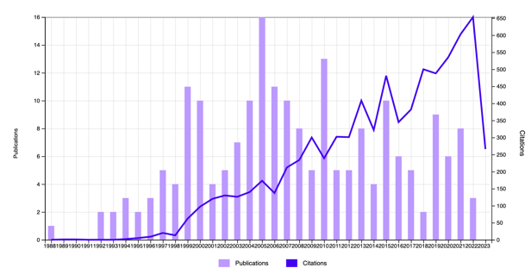
Hi-index: 49 WOS
(search with
“Osetski I OR
Osetsky Y OR
Osetskiy Y”):
53 ResearchGate https://www.researchgate.net/profile/Yuri-Osetsky
55 Google Scholar https://scholar.google.com/citations?hl=en&user=LCAiCL4AAAAJ
https://orcid.org/0000-0002-8109-0030

